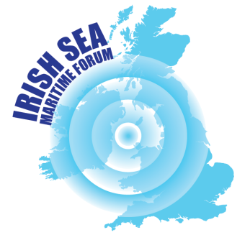
IRISH SEA MARITIME FORUM
BIENNIAL CONFERENCE
Pierhead Building
National Assembly for Wales, Cardiff
10.00am – 4.00pm
Tuesday 15 January, 2019

We welcome you to join us for the first Irish Sea Maritime Forum Biennial Conference to be held in Wales. We are delighted to have the opportunity to host this in the spectacular Pierhead building that is part of the National Assembly for Wales estate in Cardiff. The event aims to bring together stakeholders from across the Irish Sea to learn about issues of current and shared interest and contribute to work updating the ISMF’s 2012 Irish Sea Issues and Opportunities report.
The morning session provides an update from across the Irish Sea on marine planning and the development of the network of Marine Protected Areas and will enable delegates to discuss issues and opportunities associated with these important new arrangements. Over lunch delegates will be able to view an exhibition of Irish Sea related projects and meet some of the partners that have been involved with these. The afternoon session spotlights the latest UK Climate Change Impact Programme projections and associated activity in the Irish Sea region including the response of coastal authorities in Wales and work associated with protection of coastal heritage. There will then be an opportunity for delegates to contribute their thoughts on what Brexit might mean for the Irish Sea region and the role that the ISMF might play in relation to these. To conclude there will be a presentation on the new Irish Sea Centre that is being established in the Isle of Man and plans for the ISMF conference that will be held in the Isle of Man in 2020.

The conference is free of charge. We gratefully appreciate the support of David Melding AM Shadow Cabinet Secretary for Housing, Heritage, Culture and Media in sponsoring this event in the Pierhead building.
For more information and to reserve your place please follow the link below:
http://www.irishseamaritimeforum.org/update-irish-sea-maritime-forum-biennial-conference/
or contact info@irishseamaritimeforum.org

or contact

info@irishseamaritimeforum.org

DRAFT PROGRAMME

Morning Session

9.30 Arrival and coffee

10.00 Welcome
David Melding AM
Senator Gerry Horkan, ISMF Chair

10.15 Irish Sea Marine Planning (MP)Update
Dr Heather Ritchie and Dr Linda McElduff, University of Ulster

10.30 Irish Sea Marine Protected Area (MPA) Update
Sue Kidd and Caroline Salthouse, ISMF Secretariat

10.45 Panel discussion with MP/MPA government representatives

11.15 Refreshments

11.45 Stakeholder reflections on MSP/MPA developments in Irish Sea Region
2 X 20 minute workshops

12.30 Lunch and Irish Sea Project Exhibition

Afternoon Session

14.00 UK Climate Change Impact Programme Updated Projections
Dr Judith Wolf, National Oceanographic Centre

14.10 Climate Change and Coastal Communities – A view from Denbighshire
Wayne Hope, Denbighshire County Council.

14.20 Climate Change and Coastal Heritage – a view from the CHERISH project
Dr Toby Driver, Royal Commission on the Ancient and Historical Monuments of Wales

14.30 Stakeholder reflections on climate change and the Irish Sea Region
Workshop

15.00 Refreshments

15.20 Brexit Issues and Opportunities for the Irish Sea – thoughts on a postcard

15.30 Irish Sea Centre and 2020 ISMF Conference in Isle of Man
Roger Pullin and Terry Holt, ISC - Sue Kidd, ISMF Secretariat

15.40 Reflections on the day
Cllr Flo Clucas OBE, Past ISMF Chair
Senator Gerry Horkan, ISMF Chair

16.00 Close

